**USE CASE DIAGRAM FOR PBL PROJECT**

**TOPIC: CONTACTLESS DOORBELL AND DOORLOCK**

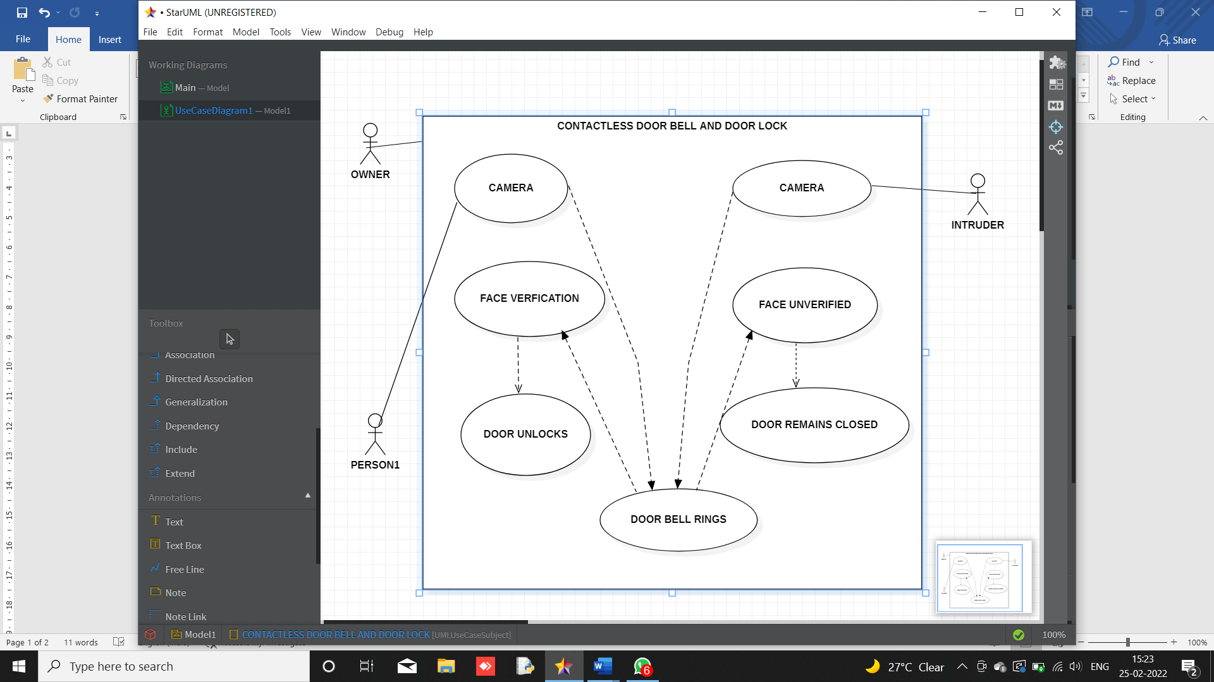

SSSS